Candy Drop

Genre: Arcade / Puzzle

Target Audience: Everyone

Platform: Unity Mobile

Written by Wing Kei Chin

Version: 1.1

July 19, 2025

All work Copyright ©2025 by Wing Kei Chin

**Revision History**

|  |  |  |  |
| --- | --- | --- | --- |
| Version | Date | Author | Comments |
| V1.0 | Jul 19, 2025 | Wing | Created the GDD |
| V1.1 | Jul 23, 2025 | Wing | Updated the player input |
| V1.2 | Oct 14, 2025 | Wing | Updated the GDD to reflect on the game as of Sept 2025 (Term4 End – TFS)   * Red - (Not Implemented) * Yellow Changed / Added Conponents |
|  |  |  |  |
|  |  |  |  |

Table of Contents

Game Overview 4

Game Elements 4

Player 4

Enemy (Not Implemented) 4

Pickup (Not Implemented) 4

Obstacles 4

Score Ranking (Not Implemented) 4

Win 4

Lose 5

Audio 5

HUB 5

Menu 5

Game Mechanics 5

Gameplay Mode 6

Core Systems 6

Goal 7

Play Input 7

Player Mechanics 8

Gameplay System 9

Flowchart 11

# Game Overview

Candy Drop is a Plinko-style like game with candy and sweets as the theme. Candies are dropped from the top to the bottom with items, obstacles, and enemies that will affect it on the way down.

# Game Elements

Candy Drop is a 2.5D candy drop game. Candy Drop’s theme is a cute and sweet environment that makes the player feel like they are trapped in a sweet and pleasant gameplay. Candy Drop uses cartoony 2D graphics that are suitable for all ages.

### Player

* Candy drops button which will initiate the drop
* Player health reduces when it is hit by enemies

### Enemy (Not Implemented)

* Enemies pop up on random locations on the board
* Water – Increases the Candy fall speed
* Chocolate – Deducts player points by 50

### Pickup (Not Implemented)

* Pickup pop ups on random locations on the board
* Marshmallow: Plus 1 life.
* Sprinkle: Add 50 bonus points.
* Special Ability: Sugar Rush (5x points)

### Obstacles

* Wall – When candy collides with it, it will bounce back
* Bouncing platform – It will redirect the candy’s fall down direction

### Score Ranking (Not Implemented)

* 3 stars ranking: Bronze, Silver, Gold base on final score

### Win

* Health does not equal 0

### Lose

* Health equal to 0

### Audio

* Audio will use cute cartoony sounds for each element (Used Calm Music – Need to change to more cute music)
* Each component will have their own audio (Not Implemented)
* Each unique movement of the character will have a corresponding sound for the action (Not Implemented)

### HUB

* Life – Displays the player’s life, start with 3, max 5
* Point - Displays the player score

### Menu

* Start menu – Loads with the game title
* Instruction menu – Displays the instructions of the game
* Setting menu – Displays the music control (Main, Music, Sfx)
* Credit menu – Displays the credit
* End Screen – Exits the game
* Pause Menu – Pause game during gameplay (Not Implemented)

# Game Mechanics

* Drop and Bounce
  + Player chooses the column for the candy to drop from the top
  + Gravity pulls the candy down
  + On collision with obstacles (like board, wall), the candy will bounce off
* Avoid Enemies (Not Implemented)
  + Water – Increases the Candy fall speed
  + Chocolate – Decreases points
* Slot effect
  + Bottom of the board will have many slots. Each has a different effect when candy lands on it
    - 10 points
    - 20 points
    - 50 points
    - Extra Candy
    - Deducts points (-100)
    - Lose 1 life
* Power ups (Not Implemented)
  + Marshmallow – Plus 1 life
  + Sprinkle – Gives extra points
* Special Abilities (Sugar Rush) (Not Implemented)
  + 5x points
* Reward System
  + Bottom slot reward differs depending on which one the candy land on
  + Collect power ups on the way to receive different rewards
  + When on collision on enemies, depending on the effect, each will have different damage on the player

# Gameplay Mode

* Game mode type
  + Single player
  + Turn-based
  + Arcade-style drop system
* One candy drop per turn
* Scores survival game – Aim for the highest score
* Game ends when lives = 0

# Core Systems

* Start turn
  + Player’s turn begins.
* Select column
  + Player chooses which column to drop the candy into.
* Candy fall and bounce
  + Candy starts to fall from the top of the board
  + It will bounce off obstacles and walls as it collides
* Check on enemy / obstacle’s collision
  + If the candy hits an enemy / obstacle (e.g., Water, Chocolate):
    - Apply Enemy Effect:
      * Water: Increases fall speed.
      * Chocolate: Deducts points.
  + If no enemy is hit, proceed to check for power-ups.
* Check on power up pickup
  + If the candy touches a power-up (e.g., Marshmallow, Sprinkle):
    - Collect Power-Up: Plus 1 life.
      * Sprinkle: Add 50 bonus points.
* Check if candy reaches the bottom slot
  + If the candy reached the bottom slot:
    - Trigger and resolve slot effect:
      * Possible effects:
        + 100 or 200 points
        + Extra candy
        + Point deduction (-100)
        + Lose 1 life
* Check for Special Abilities (Sugar Rush)
  + If item is picked up on the way down, apply:
    - 5x points bonus at the end of the turn
* End Turn
  + Player’s end turn
  + Prepare for next drop and evaluate game over condition (if lives = 0)

# Goal

* Avoid all obstacles and make your way through to the bottom of the board.
* Finish the game without dying.
* Trying to achieve the highest score.

# Play Input

* Touch
  + Select on the menu item
  + Activate play turn
* Touch and Hold (Swipe left or right)
  + Select the column to drop the candy
* Tap
  + When drop, if you tap, you will bounce in a opposite direction
  + Pause button
    - Activate the pause menu
* Release
  + Drop the candy

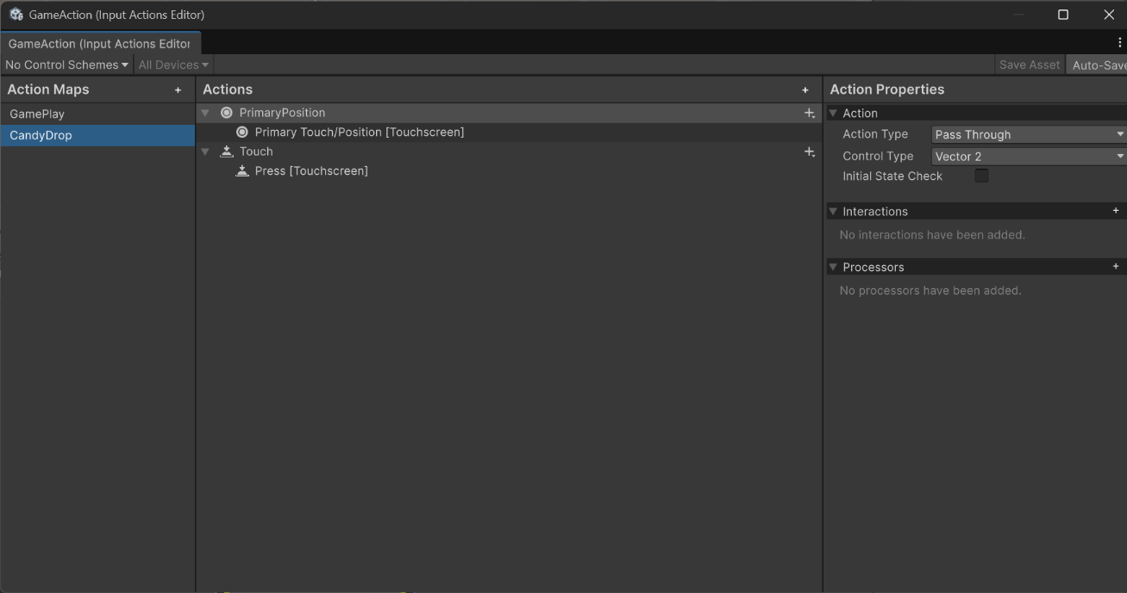

# Player Mechanics

* Start turn
  + Player’s turn begins.
* Select column
  + Tap to activate turn
  + Select column to drop by holding the touch input
  + Candy release by release the hold
  + Candy falls down by gravity
* Collision
  + If the candy hits a wall / platform:
    - On hit – Bounce in other directions
    - If no hit – Continue falling
  + If the candy hits an enemy / obstacle (e.g., Water, Chocolate):
    - Apply Enemy Effect:
      * Water: Increases fall speed.
      * Chocolate: Deducts points.
  + If no enemy is hit, proceed to check for power-ups.
* Check on power up pickup
  + If the candy touches a power-up (e.g., Marshmallow, Sprinkle):
    - Collect Power-Up:
      * Marshmallow: Plus 1 life.
      * Sprinkle: Add 50 bonus points.
      * Sugar Rush: Special ability use before end of turn
* Reach bottom slot
  + Check if candy reaches the bottom slot
    - If the candy reached the bottom slot:
      * Trigger and resolve slot effect:
        + Possible effects:

100 or 200 points

Extra candy

Point deduction (-100)

Lose 1 life

* Check for Special Abilities (Sugar Rush)
  + If item is picked up on the way down, apply:
    - 5x points bonus at the end of the turn
* End Turn
  + Player’s end of turn
  + Check life
    - If life not equal 0:
      * Prepare for next drop
    - If life equal 0
      * Game over

# Gameplay System

* Start
  + Gameplay system activates
* Check if candy reaches the bottom slot
  + If the candy reached the bottom slot:
    - Trigger and resolve slot effect:
      * Possible effects:
        + 100 or 200 points
        + Extra candy
        + Point deduction (-100)
        + Lose 1 life
* Check for Special Abilities (Sugar Rush)
  + If item is picked up on the way down, apply:
    - 5x points bonus at the end of the turn
* Update score and life
  + Apply effect and update points and life
* Game loop check
  + If life not equal 0:
    - Prepare for next drop
  + If life equal 0
    - Game over

# Flowchart

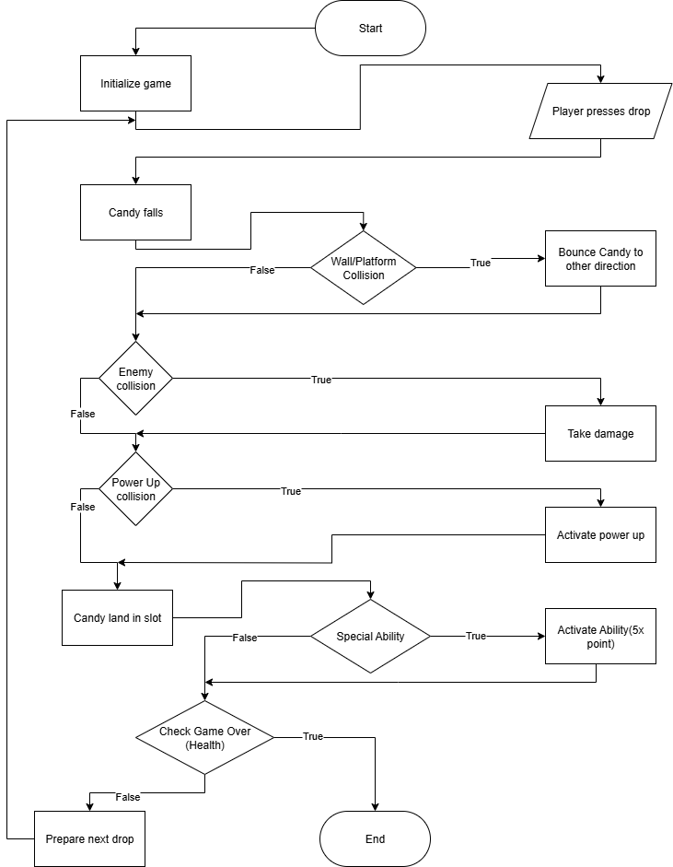

Flowchart of Core Systems.

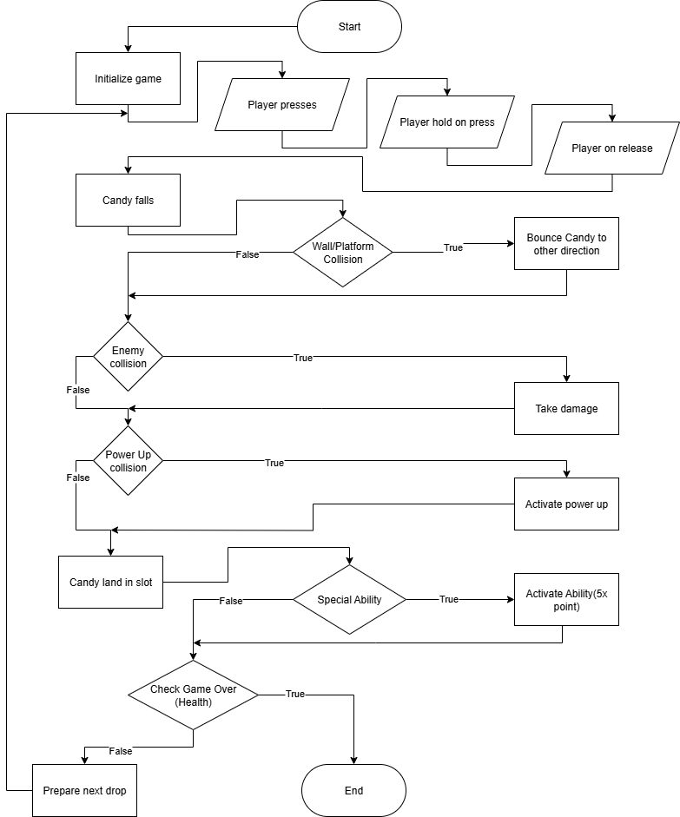

Player Mechanics Flowchart

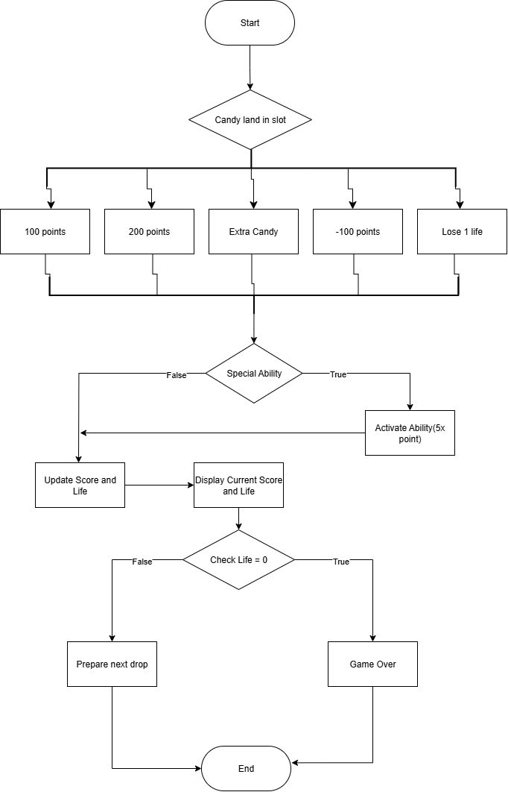

Gameplay System Flowchart